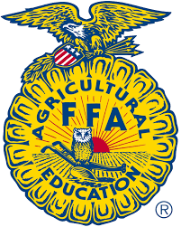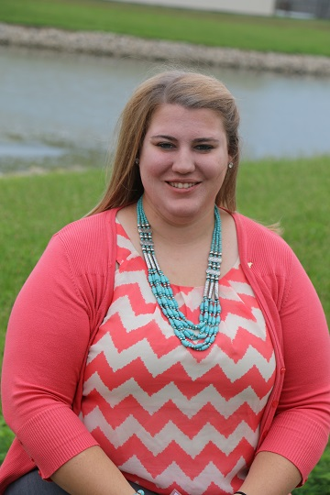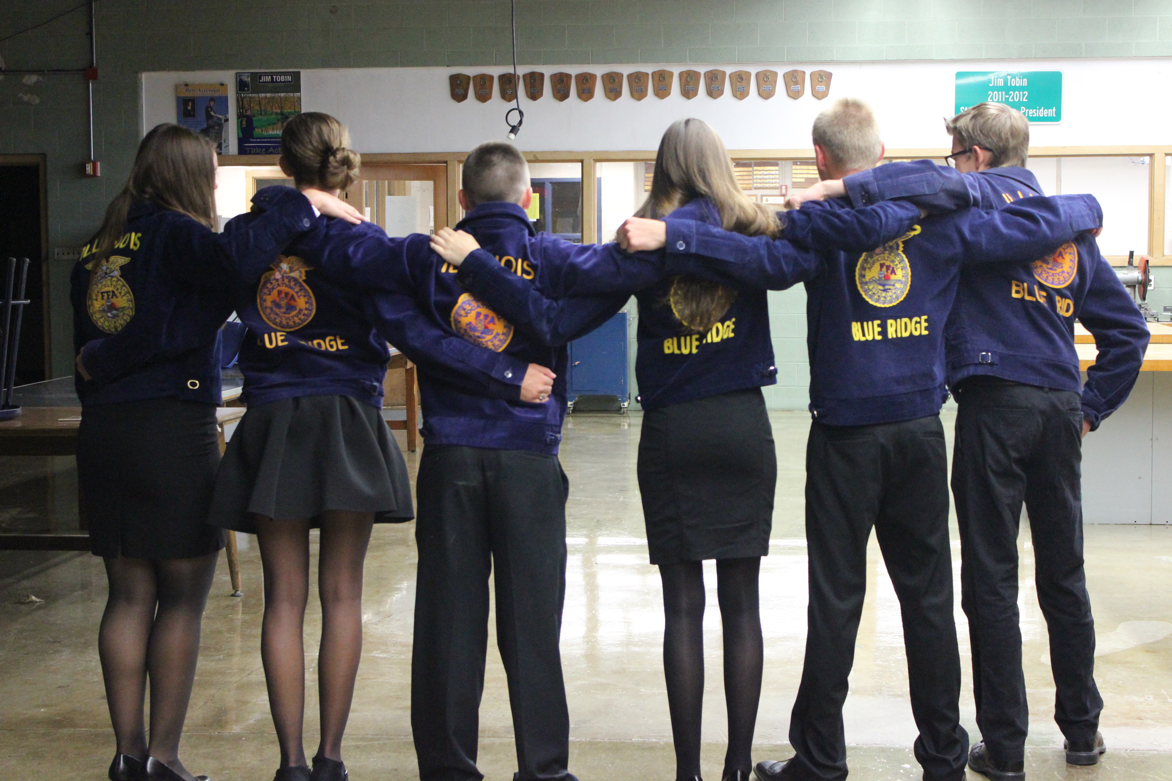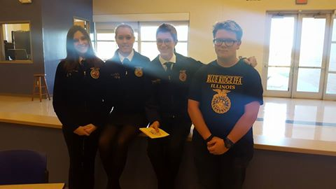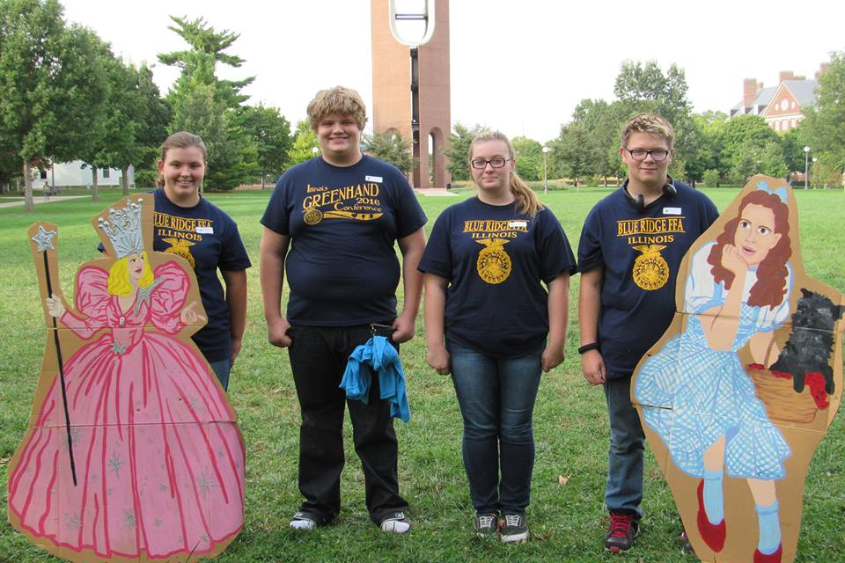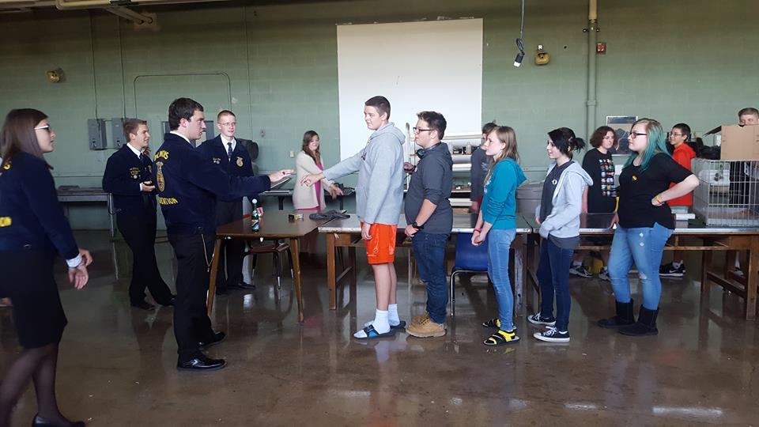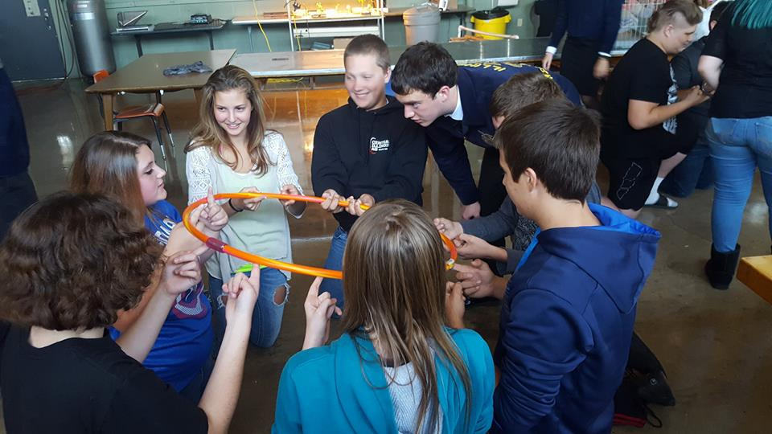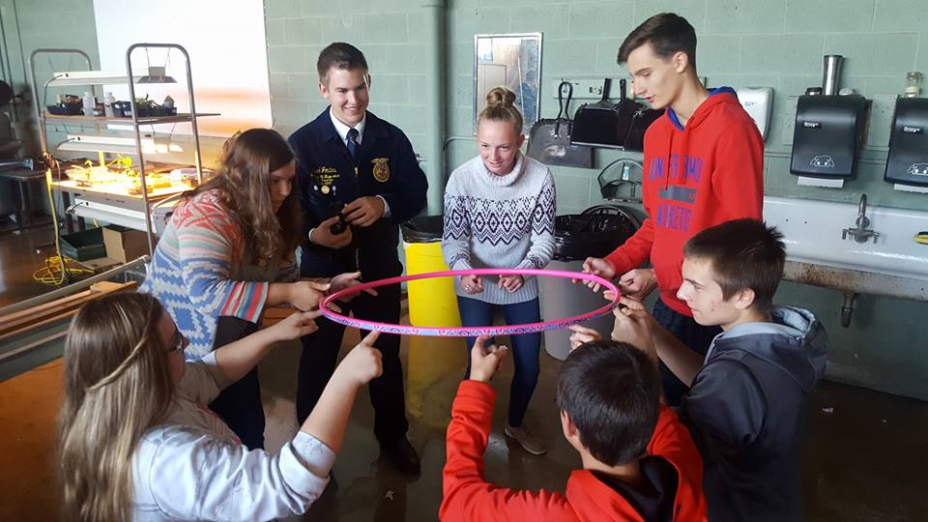

Ms. Jacalyn Meisner is our new Ag Teacher and FFA Advisor at Blue Ridge! She’s from Jerseyville, Illinois and was part of the Jerseyville FFA Chapter and Section 15 Officer Team when she was in FFA. Ms. Meisner grew up on a livestock and grain operation, but spent majority of her time with the cattle, goats, and pigs preparing them for shows. She showed Shorthorn cattle nationally with her two siblings and pigs and Boer goats locally. Ms. Meisner has her bachelor’s degree in Elementary Education from EIU and a Master’s degree from U of I. She is looking forward to being a part of the community and watching her students become successful.

**College:** EIU for Bachelors

U of I for Masters

**Favorite CDEs:** Meats Evaluation and Parliamentary Procedure

**SAE:** Beef Production Ent., Specialty Animal Production (now it’s Goat), and Diversified Livestock Ent.

Fun Facts:

## New Year, New Advisor,

## New Beginnings

# Meet the New Advisor!

**Ms. Jacalyn Meisner**

**Blue Ridge Ag Teacher and FFA Advisor**

August/September 2016

Blue Ridge Chapter Chatter

Our 2016-2017 Officer Team during our summer workshop

Leadership Training School (LTS)

September 26th was a busy night with sports and several activities students were involved with, however 3 members of our officer team and 1 of our new Greenhand Members took time off to attend the Section 16 Leadership Training School (LTS).

At the event students attended workshops lead by section advisors, extension leaders, past state officers, and even our state candidate for National FFA Office. Our Blue Ridge members gained some great ideas and left feeling energized and ready to share their ideas with our chapter.

**Secretary Sydney Paris, Treasurer Grace Holtz, Vice President Parker Otto, and Greenhand member Devyn Dumas**

It sure feels like time has flown by since the start of school in August! So far the Ag Classes have been busy at work with learning new things.

* The two Intro to Ag classes have been studying about careers in the Ag Industry, FFA and opportunities FFA has, and Soils.
* Ag Business not only created their own restaurant from learning about business structures, but they did so as a class and researched what it would take to start a business out of high school. They are currently working on a personal finance unit and played a competitive game of Monopoly while keeping records and writing checks to peers.
* BSAA (Biological Science Applications in Ag) have been taking a look at the working of a plant at a microscopic level and identifying parts of a cell, flower anatomy, reproduction of flowers, and seed germination. Students completed a germination lab identifying perfect conditions and what their mystery seed was.
* Conservation has been hard at work with their Natural Resources unit. Students taught their peers about different types of (next page) Natural Energy; they created windmills from their own designs, and identified uses of land. Members of the class are now working on a Soils unit.

It’s been a “hit the ground” running kind of start, but so far all of the classes are working hard and investigating multiple areas of agriculture.

Four Greenhand members of the Blue Ridge FFA chapter attended the Greenhand Conference September 21 at the University of Illinois in Champaign-Urbana. Members in attendance from left to right include Katie Cole, Alexzander Lashbrook, Audrie McClain, and Devyn Dumas.

This year the Greenhand Conference theme was based around the

Wizard of Oz.

Students attended workshops centered on the Road to Success: Heart, Brain, and Courage theme. Students were encouraged to consider their passions and to discover how FFA involvement and academic achievement can equip them to achieve their dreams.

Upon leaving the conference students shared memories of friends made and ideas of how they can be more involved.

Greenhand Conference

### What’s been happening?

Stay in the Know:

Website: blueridgeffa.weebly.com

Coming Soon:





Blue Ridge FFA

September 27th Blue Ridge had 4 special guests come in to energize our Ag Students during our Chapter Visit. State FFA Vice President Paxton Morse, Section 16 President Rebekah Nash, Section 16 Reporter Reed Jostes, and Section 16 Sentinel Eston Coe came for Chapter Visits and got our students thinking about leadership and maximizing their potential within the FFA.

**October:**

4: ADM Lunch

6: Homecoming Parade

7: Homecoming Football Game

8: Homecoming Dance

12: Ag Sales, Greenhand Quiz Bowl, and SAE Expo

14: Parkland Open House

18: Chapter FFA Meeting 6-7pm

19-22: National FFA Convention

Upcoming Events:

#### Chapter Visits

In hac habitasse platea dictumst.